#### DATABASE DOCUMENT

--> Login to UB_Prod database jpplurbanbookdb using reminna.

For Basic Database scenario, follow the below steps:

|  |  |  |
| --- | --- | --- |
| Sr.No | Table Name | Details can be fetched |
| 1 | Ub_flight_book | All details related to booking. |
| 2 | Ub_passenger_details | All details regarding passenger |

For Supplier Logs we have found in different scenarios for different type of logs. Please find the same below.

Step 1 : SELECT DISTINCT TYPE_OF_LOGS FROM UB_SUPPLIER_LOGS

From this we will get to know the details of supplier logs

Step 2 : Here we will take the supplier log as per our issue and we will execute the below command

SELECT * FROM UB_SUPPLIER_LOGS WHERE TYPE_OF_LOGS=”here we will add that type of logs”;

|  |  |
| --- | --- |
| Issue | Related type_of_logs |
| Search related issue | Flight_search |
| Booking related issue | Flight_booking |
| Cancellation related issue | EMT_Cancellation |
| For miles accrual issue (miles has been accrued or not) | CRIS_Accrual, CRIS_Accrual_refund, CRIS_Accrual_cancel |
| For miles not released or mismatch related issue | CRIS_Onhold_Release |
| Cancellation related issue | EMT_Cancellation and EMT_CancellationInfo |

**EXAMPLES of supplier Logs shown below:**

**Example 1 :- For flight search**

SELECT * from jpplurbanbookdb.UB_SUPPLIER_LOGS where CREATED_DATE between '2019-04-02 10:00:00' and '2019-04-02 10:30:00' and TYPE_OF_LOGS='flight_search';

Isse hame uska request and response milega .

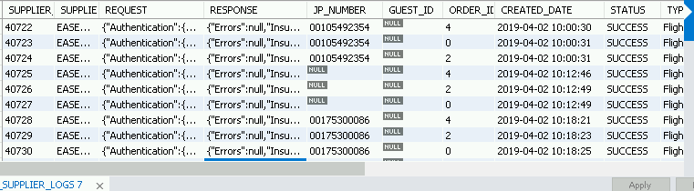

**Example 2 :- For Flight booking**

SELECT * from jpplurbanbookdb.UB_SUPPLIER_LOGS where CREATED_DATE between '2019-04-02 10:00:00' and '2019-04-02 12:30:00' and TYPE_OF_LOGS='flight_booking';



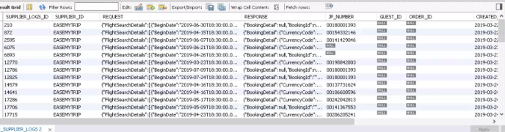

Isse hame booking related request and response milega sari booking related details milegi yaha.

**Example 3 :- For Cris_Onhold_release**

Ye scenario me hamare liy sabse important hota hai pehle PMA ID pata krne then uske base par hi hum actual request and response find kar payenge.

So, first of all we will understand what is PMA_ID

PMA_ID ke paas kitna points dena hai wo information store hoti hai

Note: jaha bhi cris accrual, redemption, release mile hua ya nai aise cases me hame uska request and response PMA ID se hi milega.

--> First of all we have to find the PMA_ID for the same we have to fire the below given query. Please note that we need to get the fb_booking_ref_no to fire the below query. FB_booking_reference_no we will get from ub_flight_book table by executing the query, SELECT * FROM jpplurbanbookdb.ub_flight_book where Order_ID=”'50000059435'

Then from the FB_booking_reference_no we will get the PMA ID by firing the below command.

SELECT * FROM jpplurbanbookdb.ub_pax_seg_book_detail where FB_BOOKING_REF_NO = 286916;



Note that PMA_ID and verify the same PMA_ID in request column of UBA_Cris_Onhold_release type of logs by firing below query.

SELECT * from jpplurbanbookdb.UB_SUPPLIER_LOGS where TYPE_OF_LOGS='UBA_CRIS_ONHOLD_RELEASE' and CREATED_DATE between '2019-12-17 19:00:00' and '2019-12-17 19:10:00';

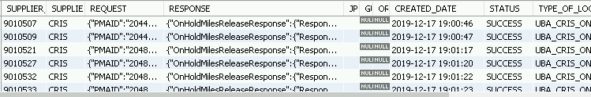

Isme request me hamara PMA_ID dhundne ka phir uska response dekhne ka.

Example 4 :- For price related

Here, we will check the type of logs = 'Flight_PriceCheck'

SELECT * from jpplurbanbookdb.UB_SUPPLIER_LOGS where CREATED_DATE between ‘2020-04-02 08:00:00’ and ‘2020-04-02 11:30:00’ and type_of_logs='Flight_PriceCheck';

Example 5 :- For FTR Related:

Pehle inspect element me jake dkehne ka then code me dekhne ka to samjhega ke kaunse stored procedure me hora hai issue

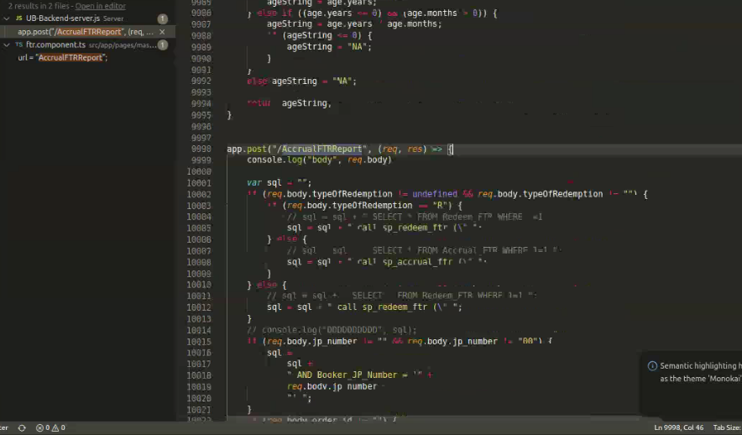.

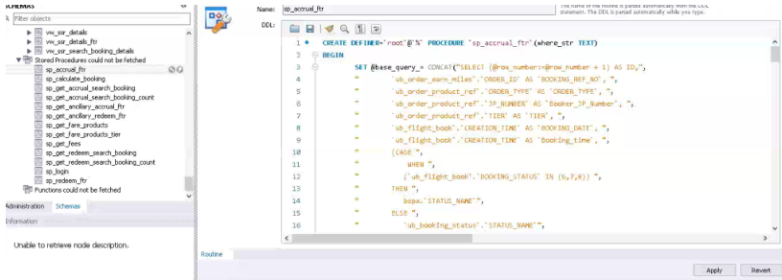

Note :-

|  |
| --- |
| 1. Flight search me request ke base pr hi query banayenge na ki respinse ke q ki isme request chota hota hai and response bahot bade hain. |
| 1. Aur isme hame wo type ke cases milenge jisme cx bolta hai refundable tha but nai hota hai waise me to isme response dekh kr krenge hum. |
| 1. Booking se pehle price recheck ka call jata hai uske liy niche ki query hai (user ne jo flight select kiya hai uska price wai hai ya badha hai uske liy ye call hota hai) |
| 1. Request, response and creation date iske base pr hi search krte hain mostly kabi kabi SID pr bhi hota hai |
| 1. Search related issue hai to fligfht search log dekho isme request and response milega. Agar booking related hai to flight booking request log dekho aur agar cancel hai to EMT Cancllation me dekho. |

--------------------------******************************------------------------------